









Bug ID: 01

[Weight-Controller**][Update Weightage]** API doesn’t return validation error for null values in data fields of request body in update weightage.

**Description**

**Environment :**

Base URL: http://localhost:8080

**Pre-Conditions:**

1. System is running
2. Admin is logged in

# Steps to reproduce:

1. Fill the field for weight data as null

Request Body:

{

"dailyTaskEvaluationWeightage": null,

"miniProjectEvaluationWeightage": 20,

"midProjectEvaluationWeightage": 50,

"finalProjectEvaluationWeightage": 30,

"domainWeightage": "",

"managerEvaluationWeightage": 15,

"trainingWeightage": 67,

"hrInterviewEvaluationWeightage": 33

}

1. Send API request to [/api/v1/weight].

# Expected Result:

1. API should return validation error.

Response Body:

{

"status": "NOT_FOUND",

"message": " "

}

Status Code: 404 Not Found"

# Actual Result:

1. API returns no error.

Status Code: 200 OK

**Attached Document:**

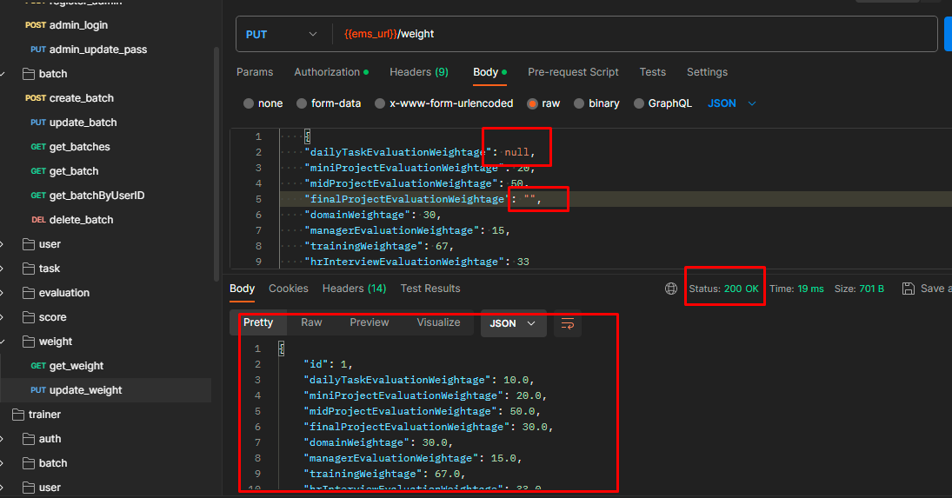

Bug ID: 02

[Weight-Controller][Update Weightage] API does not have authorization for trainer role in update weightage.

**Description**

**Environment :**

Base URL: http://localhost:8080

**Pre-Conditions:**

1. System is running
2. Traner is logged in

# Steps to reproduce:

1. Login as trainer
2. Fill the field for weight data

{

"dailyTaskEvaluationWeightage": 10,

"miniProjectEvaluationWeightage": 20,

"midProjectEvaluationWeightage": 50,

"finalProjectEvaluationWeightage": 30,

"domainWeightage": 30,

"managerEvaluationWeightage": 15,

"trainingWeightage": 67,

"hrInterviewEvaluationWeightage": 33

}

1. Send API request to [/api/v1/weight].

# Expected Result:

1. API should return changes made for weightage as trainer logged in.

Response Body:

{

"id": 1,

"dailyTaskEvaluationWeightage": 10.0,

"miniProjectEvaluationWeightage": 20.0,

"midProjectEvaluationWeightage": 50.0,

"finalProjectEvaluationWeightage": 30.0,

"domainWeightage": 30.0,

"managerEvaluationWeightage": 15.0,

"trainingWeightage": 67.0,

"hrInterviewEvaluationWeightage": 33.0

}

Status Code: 200 OK

# Actual Result:

1. API returns an authorization error.

Status Code: 403 Forbidden

**Attached Document:**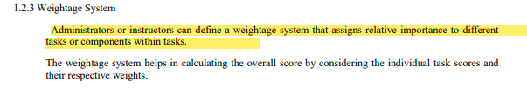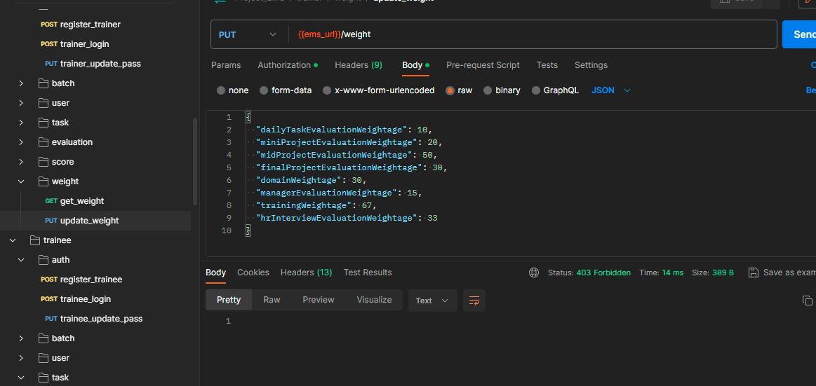

Bug ID: 03

[Weight-Controller][Get Weightage] API does not have authorization for trainer role in get weightage.

**Description**

**Environment :**

Base URL: http://localhost:8080

**Pre-Conditions:**

1. System is running
2. Traner is logged in

# Steps to reproduce:

1. Log in as trainer
2. Send API request with GET method to [/api/v1/weight].

# Expected Result:

1. API should return weightage configuration.

Response Body:

{

"id": 1,

"dailyTaskEvaluationWeightage": 10.0,

"miniProjectEvaluationWeightage": 20.0,

"midProjectEvaluationWeightage": 50.0,

"finalProjectEvaluationWeightage": 30.0,

"domainWeightage": 30.0,

"managerEvaluationWeightage": 15.0,

"trainingWeightage": 67.0,

"hrInterviewEvaluationWeightage": 33.0

}

Status Code: 200 OK

# Actual Result:

1. API returns an authorization error.

Status Code: 403 Forbidden

**Attached Document:**



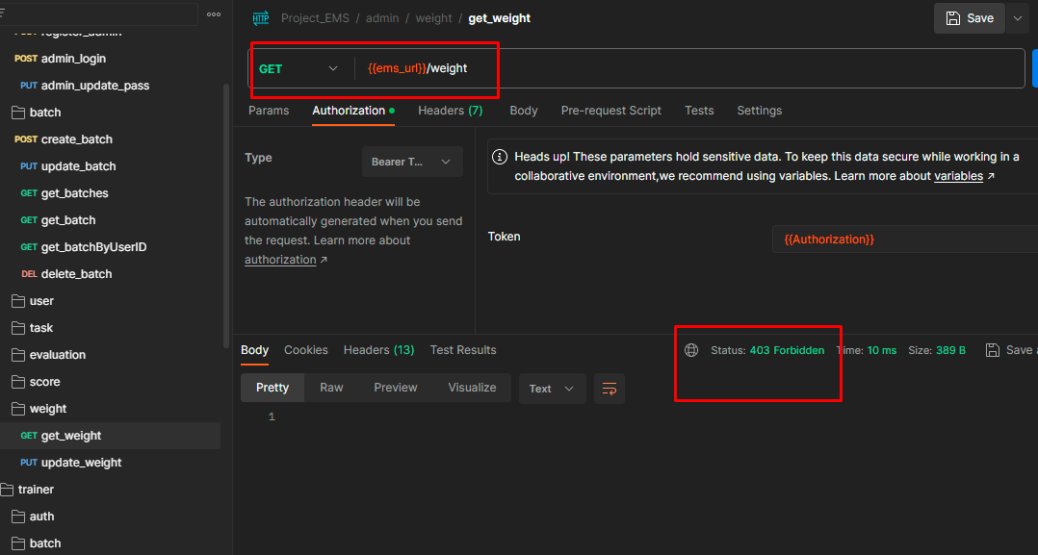

Bug ID: 04

[Evaluation-Controller][Get Evaluation] API does not return all final project evaluation data upon creating final project evaluation from “upload task evaluation” API containing task type as FINAL_PROJECT.

**Description**

**Environment :**

Base URL: http://localhost:8080

**Pre-Conditions:**

1. System is running
2. Admin is logged in

# Steps to reproduce:

1. Create final project evaluation from upload task evaluation API endpoint [/api/v1/evaluation] with taskType as FINAL_PROJECT
2. Send API request to [/api/v1/evaluation?batchId=7&taskType=FINAL_PROJECT] 

# Expected Result:

1. API should fetch all data for final project.

# Actual Result:

1. API doesn't fetch data for the final project created by the “upload task evaluation” API containing taskType=”FINAL_PROJECT”.

**Attached Document:**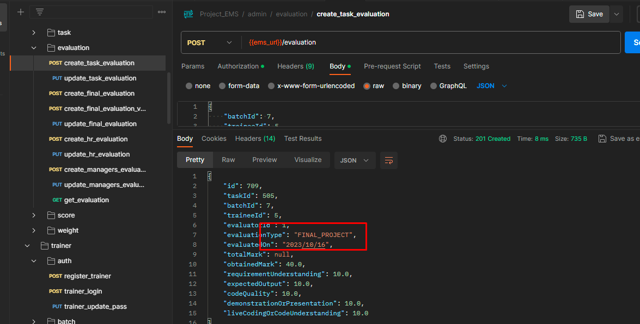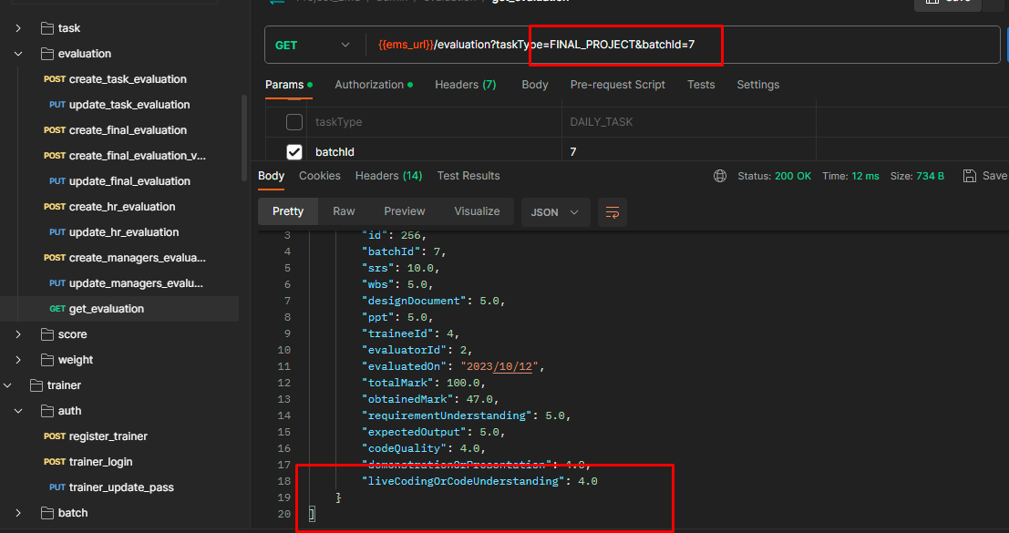

Bug ID: 05

[Evaluation-Controller][Get Evaluation] API accepts invalid batchId in parameter and shows status 200 OK.

Description

**Environment :**

Base URL: http://localhost:8080

**Pre-Conditions:**

1. System is running
2. Admin is logged in

# Steps to reproduce:

1. Send API request to [/api/v1/evaluation?batchId={batchId}&taskType={taskType}] with invalid batchId in parameter.

# Expected Result:

1. Response data should be unavailable.

Status Code: 404 Not Found

# 

# Actual Result:

1. Response data is empty & status is showing OK.

Response Body:[]

Status Code: 200 OK

**Attached Document:**

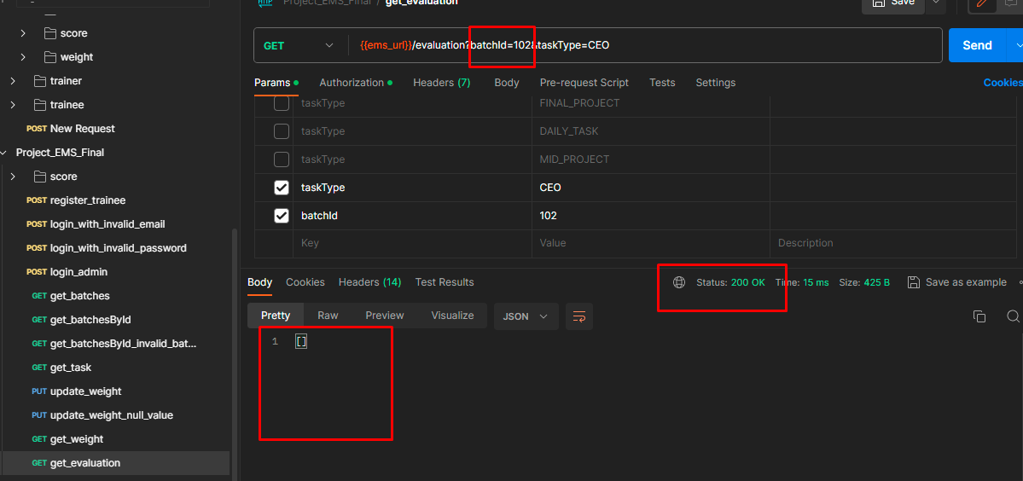

Bug ID: 06

[Final-Score-Controller][Generate Score] API response status code is incorrect when using recalculate=true in parameter for generate score.

Description

**Environment :**

Base URL: http://localhost:8080

**Pre-Conditions:**

1. System is running
2. Admin is logged in

# Steps to reproduce:

1. Send API request to [/api/v1/final-score/8?recalculate=true]. 

# Expected Result:

1. API should generate a recalculated score with status code 200 OK.

# Actual Result:

1. API returns with 403 Forbidden status code.

**Attached Document:**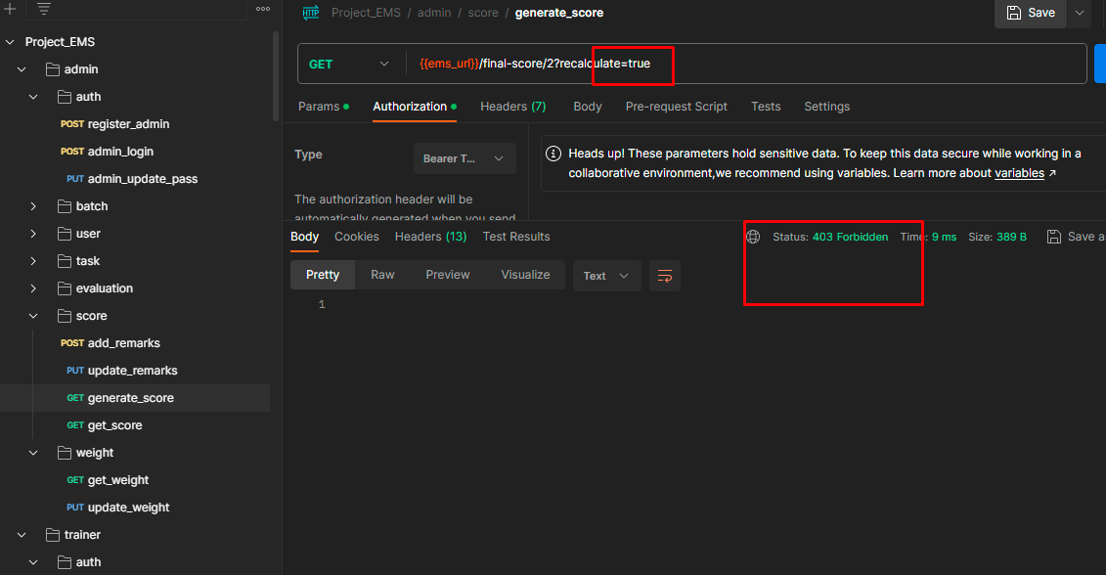

Bug ID: 07

[Final-Score-Controller][Generate Score] API response status code is incorrect when sending an id having no data for generate score.

Description

**Environment :**

Base URL: http://localhost:8080

**Pre-Conditions:**

1. System is running
2. Admin is logged in

# Steps to reproduce:

1. Send API request with a id having no data to [/api/v1/final-score/4?recalculate=false]

# Expected Result:

1. The response body should be empty with status code 204

Response Body:[]

Status Code: 204 No Content

# Actual Result:

1. The response body is empty with status code 200

Response Body: []

Status Code: 200 OK

**Attached Document:**

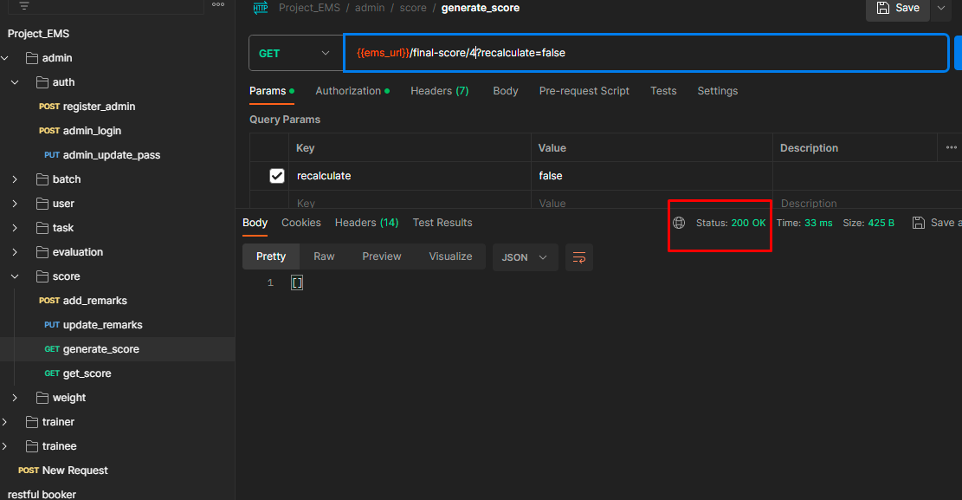

[Within scope ends]

Bug ID: 08

[Auth-Controller][Update Password] API allows unauthorized user to update the password of another user.

Description

**Environment :**

Base URL: http://localhost:8080

**Pre-Conditions:**

1. System is running

# Steps to reproduce:

1. Login with trainee's credentials

{ "email":"trainee@gmail.com",

"password":123456 }

1. Fill valid admin's data for update password
2. Send API request to [/api/v1/auth/update-password]

# Expected Result:

1. API should not allow one user to update other user's password & return an authorization error.

Response Body:

{

"message": " "

}

Status Code: 403 Forbidden"

# Actual Result:

1. API allows user to update other user's password

Status Code: 200 OK

**Attached Document:**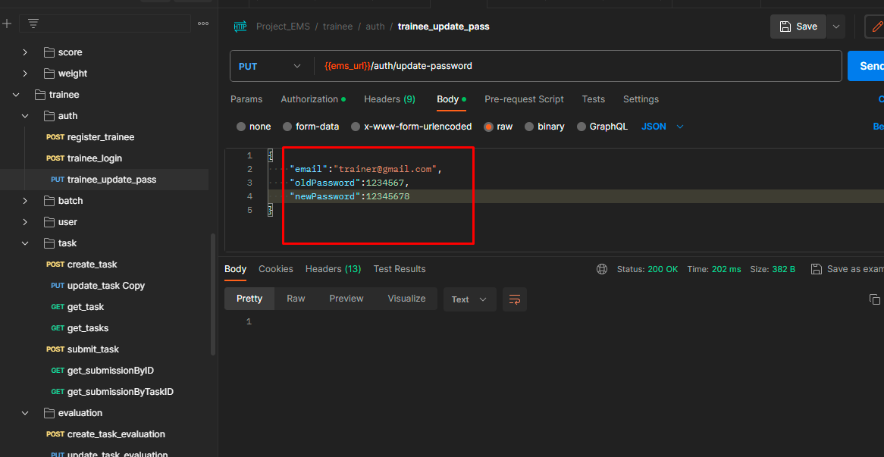

Bug ID: 09

[Task-Controller][Submit Task] API accepts non-existent taskId/traineeId in request body submit task API.

Description

**Environment :**

Base URL: http://localhost:8080

**Pre-Conditions:**

1. System is running
2. Trainee must be logged in

# Steps to reproduce:

1. Fill request body with non-existent traineeId/taskId
2. Send API request to [/api/v1/task/submit].

# 

# Expected Result:

1. API should not accept non-existent traineeId/taskId

Response Body:

{

"status": "BAD_REQUEST",

"message": " “

}

Status Code: 400 Bad Request

# Actual Result:

1. API accepts non-existent traineeId/taskId

Status Code: 200 OK

**Attached Document:**

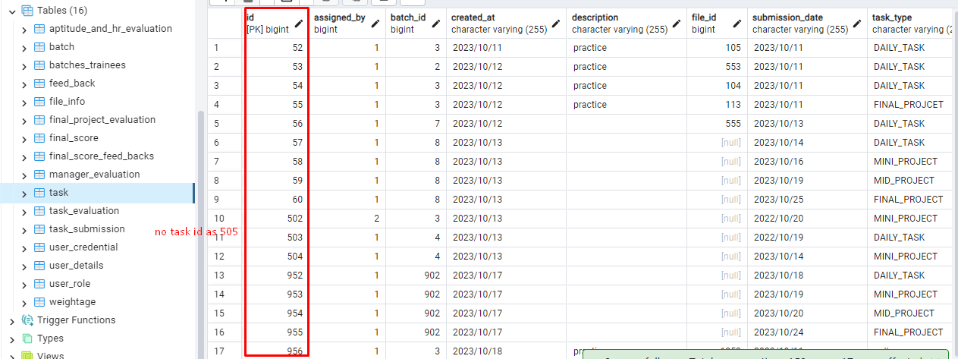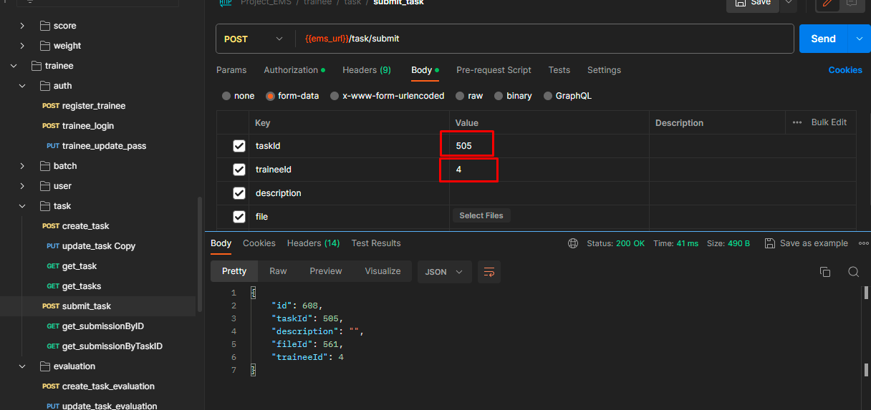

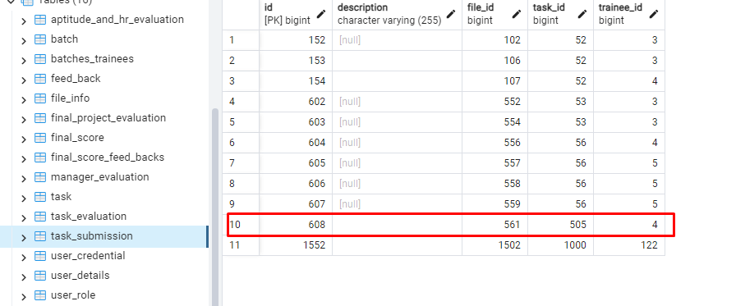

Bug ID: 10

[Evaluation-Controller][Upload HR Evaluation] Upload HR Evaluation API does not accept the value of totalMark in the request body.

Description

**Environment :**

Base URL: http://localhost:8080

**Pre-Conditions:**

1. System is running
2. Admin must be logged in

# Steps to reproduce:

1. Fill request body with valid (number) totalMark
2. Send API request to [/api/v1/evaluation/ceo]. 

# Expected Result:

1. API should respond with the requested totalMark

Status Code: 201 Created

# Actual Result:

1. API does not respond with the requested totalMark

Status Code: 201 Created

**Attached Document:**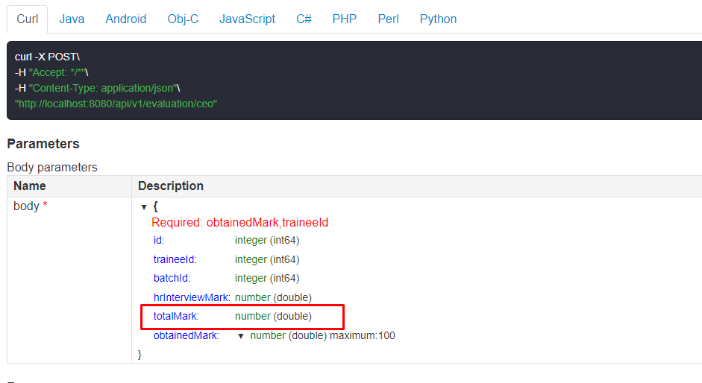

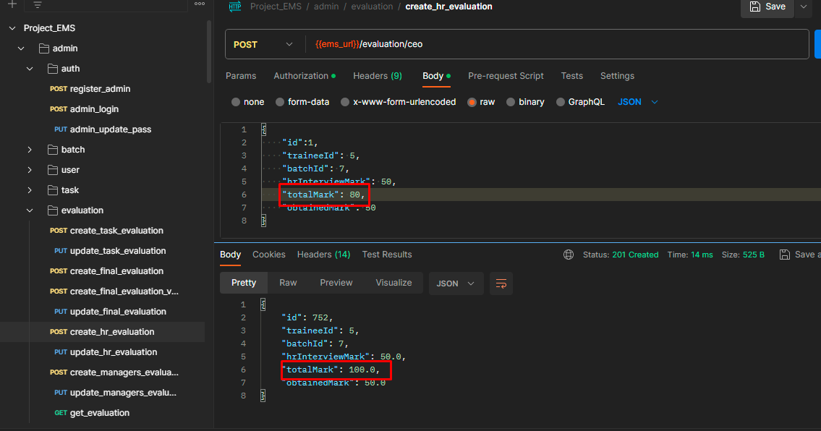

Bug ID: 11

[Evaluation-Controller][Upload Task Evaluation] API accepts requests with obtained marks greater than the total marks specified in the request body of upload task evaluation.

Description

**Environment :**

Base URL: http://localhost:8080

**Pre-Conditions:**

1. System is running
2. Admin must be logged in

# Steps to reproduce:

1. Fill the request body with greater obtained mark than total mark
2. Send API request to [/api/v1/evaluation].
3. Check the obtained mark and total mark 

# Expected Result:

1. API should reject Upload Task Evaluation with obtained marks greater than total marks.

Response Body:

{

"status": "BAD_REQUEST",

"message": "obtainedMark must be less than or equal to total marks"

}

Status Code: 400 Bad Request

# Actual Result:

1. API accepts greater obtained mark than total mark without any validation.

Status Code: 201 Created

**Attached Document:**

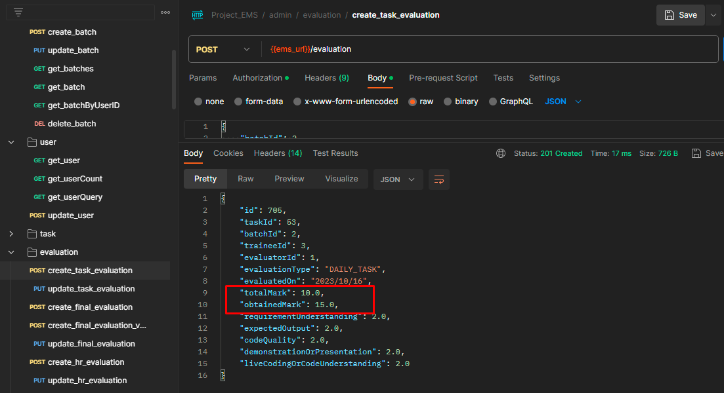

Bug ID: 12

[Final-Score-Controller][Add Remarks] API accepts request without required field in request body of add remarks.

Description

**Environment :**

Base URL: http://localhost:8080

**Pre-Conditions:**

1. System is running
2. Admin is logged in

# Steps to reproduce:

1. Fill data without one of required fields
2. Send API request to [/api/v1/final-score/feedback/402].



# Expected Result:

1. API should throw an error with a bad request.

# Actual Result:

1. API accepts request without required field in request body

**Attached Document:**

